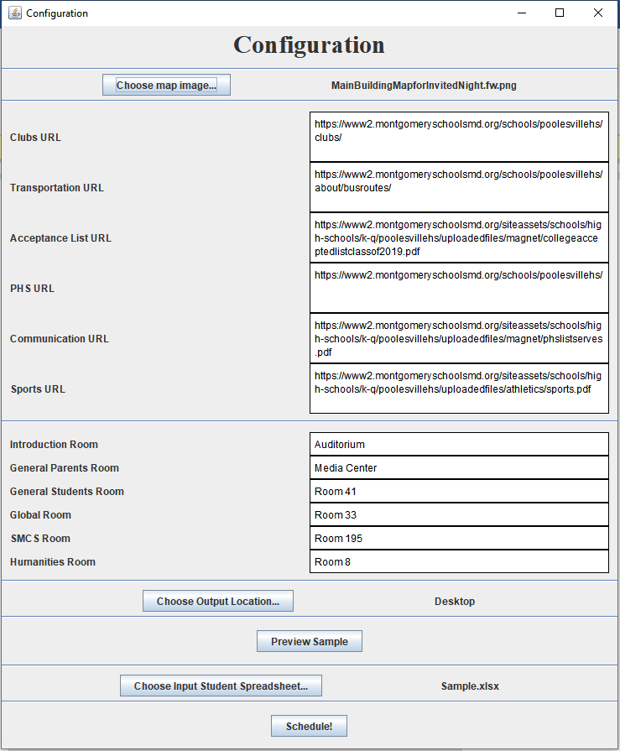

Choose your map image here. Default is the provided map image.

Insert the URLS for the QR codes here. Default is the provided links.

Insert the rooms to be used for the Invited Night. Default are the rooms used in the sample.

Choose the location where the schedules are to be stored.

Use this to preview how the schedules will look.

Input your student data.

When you are ready, click here

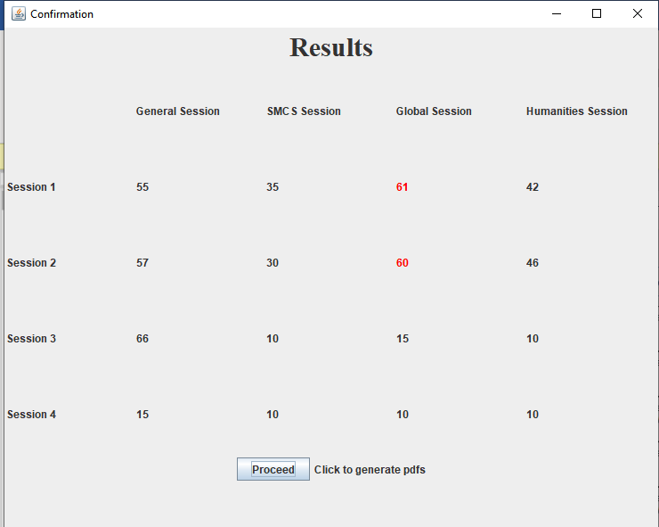

If the results are acceptable, generate the pdfs.

View the scheduler results. Red indicates overflow.